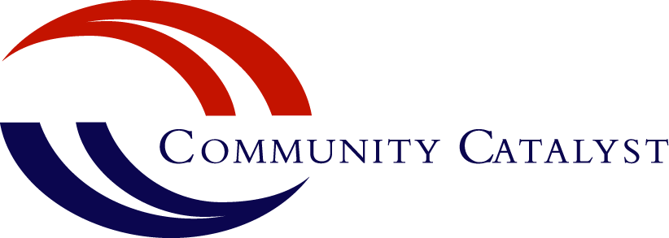

The Hospital Accountability Project

Hospitals play vital roles in their communities as health care providers, employers, major purchasers of goods and services, and powerful stakeholders with vested interests in public policy development at all levels of government. Many hospitals also have obligations to provide “community benefit” to their communities due to their tax status, mission, or other legal requirements. Because of this, hospitals can be critical partners and allies in moving policy initiatives that improve access to care and create the conditions that are necessary for thriving, healthy communities.

So, how can consumer advocates and community organizations work more effectively with hospitals? What is the right response when hospitals erect barriers to care, seem disinterested in the community’s priorities, or ignore or oppose community-identified solutions to problems? Conversely, how can we learn from innovative hospitals that actively engage and help to build stronger communities so that these stories become the rule, rather than the exception? The Hospital Accountability Project helps community organizations, advocates and others answer these questions.

Defining the Issue
A number of forward-thinking hospitals are using community benefit programs to form strategic partnerships with other providers, public health, and community partners to address the root causes of poor health in areas like housing, the built environment, and economic development—even leadership training for community members and organizations and coalition-building. But not all hospitals share this broad perspective of their role in the community. And, even hospitals with well-regarded community health programs have faced public censure for using aggressive billing and collections tactics that contribute to medical debt for low- and middle-income families. Hospital care is expensive, and financial assistance programs that offer help to people who cannot pay their out-of-pocket costs for care are a critical lifeline for uninsured and underinsured people. Dunning low- and moderate-income families for costs they cannot afford to pay is shortsighted, since it erodes their financial security and prompts them to delay care. This makes community benefit an equity issue, an economic issue, and a health issue.

Areas of Focus
The Hospital Accountability Project helps community-based organizations, consumer advocates and others working with vulnerable communities to analyze hospital and public policies related to community benefit; to develop effective strategies for engaging hospitals, public health leaders, strategic allies, and policymakers on areas ripe for change; and to lift up promising practices and address ongoing barriers to care and community engagement.
Our current priorities include:

- Ensuring that community members and partners—particularly those from or representing vulnerable populations—have a strong voice and receive the support they need to participate in the planning processes and programs hospitals use to identify and address community health issues through the community health needs assessment and implementation planning process
- Increasing transparency in hospital reporting so that communities can evaluate how hospitals invest in improving community health and access to care
- Exploring the connections between equitable economic development and community benefit
- Improving hospital financial assistance (charity care), billing and collections practices to alleviate medical debt for low- and middle-income families
- Identifying opportunities to collaborate with leading community, hospital and public health leaders and organizations to identify the “next generation” of community benefit work

We do this through a variety of approaches, which include tracking and analyzing related developments in state and federal policy, developing model legislation and commentary on community benefit and financial assistance practices, and creating opportunities for local and state organizations to weigh in with policymakers on what communities need. We offer tools and resource kits that community groups, advocates and others can tailor to help community members and leaders assess the needs and strengths of their communities, develop strategies for building effective partnerships with hospitals, and get results when policies and practices need to change. We connect community leaders around the country so they can learn from each other’s work. Whenever possible, we collaborate with other stakeholders to identify best practices and support community engagement in these important programs.

Selected Resources
Putting People First: Working with Hospitals to Improve Community Health
The tools and resources in the curriculum provide an entrée for community members and organizations to understand community benefit, evaluate hospital community benefit plans, and prepare for conversations with hospital leadership.

Reviewing the Community Health Needs Assessment (CHNA): Initial Questions to Consider
This checklist outlines the basic federal requirements for hospital CHNAs and provides community advocates with a roadmap for analyzing and evaluating their hospitals’ processes.

What Does the Affordable Care Act Say about Hospital Bills?
This policy brief unpacks the federal regulations related to hospital financial assistance, billing and collections, and charges in depth and offers context into the public policy issues the regulations were intended to address.

Hospital Financial Assistance Policies: A Quick Reference Guide
This checklist highlights the federal requirements for financial assistance policies and outlines questions hospital staff and leadership may want to consider when establishing and implementing their own policies.

